**LAB : 5**

**TOPIC :**

SQL QUERIES

**Requrements :**

(a) Windows PC (Windows 7/8/10) / Mac

(b) Oracle XE database

**Implementation :**

1. **Create a table EMP with column empid, name, birthdate, email, position, and department.**

CREATE TABLE emp_table(

emp_id int,

e_name varchar(20),

email varchar(20),

birthday date,

position varchar(20),

dept_id int,

salary int DEFAULT 10000 );

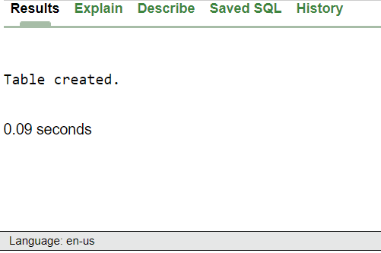

1. **Alter the table EMP, redefining the fields such that empid, name must not contain null values.**

ALTER TABLE emp_table

MODIFY (emp_id int NOT NULL,

e_name varchar(20) NOT NULL,

dept_id int NOT NULL);

-- ALTER TABLE emp_table

-- ADD salary int DEFAULT 10000

ALTER TABLE emp_table

ADD PRIMARY KEY(emp_id)

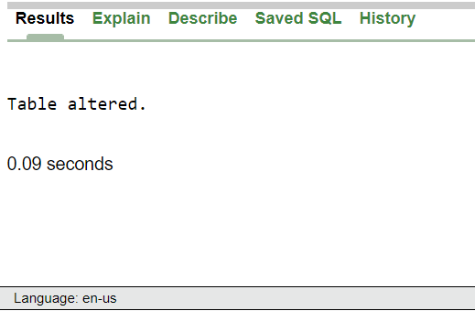

1. **Insert data in all the fields. Insert 20 records.**

INSERT INTO emp_table (emp_id,e_name,email,birthday,position,dept_id,salary)

VALUES

(1,'A','a@gmail.com',to_date('1976-05-02','YYYY-MM-DD'),'SDE1',1,75000),

(2,'B','b@gmail.com',to_date('1977-04-09','YYYY-MM-DD'),'SDE2',1,90000),

(3,'C','c@gmail.com',to_date('1974-07-08','YYYY-MM-DD'),'SDE1',2,75000),

(4,'D','d@gmail.com',to_date('1973-08-12','YYYY-MM-DD'),'SDE2',2,90000),

(5,'E','e@gmail.com',to_date('1976-05-02','YYYY-MM-DD'),'SDE1',3,75000),

(6,'F','f@gmail.com',to_date('1977-04-09','YYYY-MM-DD'),'SDE2',3,90000),

(7,'G','g@gmail.com',to_date('1974-07-08','YYYY-MM-DD'),'SDE1',4,75000),

(8,'H','h@gmail.com',to_date('1973-08-12','YYYY-MM-DD'),'SDE2',4,90000),

(9,'I','i@gmail.com',to_date('1976-05-02','YYYY-MM-DD'),'SDE1',5,75000),

(10,'J','j@gmail.com',to_date('1977-04-09','YYYY-MM-DD'),'SDE2',5,90000),

(11,'K','k@gmail.com',to_date('1974-07-08','YYYY-MM-DD'),'SDE1',6,75000),

(12,'L','l@gmail.com',to_date('1973-08-12','YYYY-MM-DD'),'SDE2',6,90000),

(13,'M','m@gmail.com',to_date('1976-05-02','YYYY-MM-DD'),'SDE1',7,75000),

(14,'N','n@gmail.com',to_date('1977-04-09','YYYY-MM-DD'),'SDE2',7,90000),

(15,'O','o@gmail.com',to_date('1974-07-08','YYYY-MM-DD'),'SDE1',8,75000),

(16,'P','p@gmail.com',to_date('1973-08-12','YYYY-MM-DD'),'SDE2',8,90000),

(17,'Q','q@gmail.com',to_date('1976-05-02','YYYY-MM-DD'),'SDE1',9,75000),

(18,'R','r@gmail.com',to_date('1977-04-09','YYYY-MM-DD'),'SDE2',9,90000),

(19,'S','s@gmail.com',to_date('1974-07-08','YYYY-MM-DD'),'SDE1',10,75000),

(20,'T','t@gmail.com',to_date('1973-08-12','YYYY-MM-DD'),'SDE2',10,90000);

SELECT *from emp_table ;

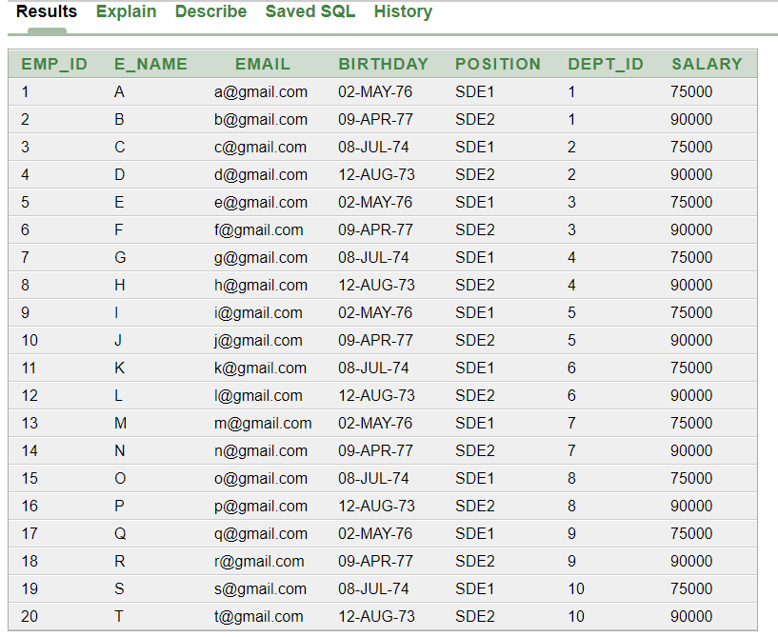

1. **Create another table DEPARTMENT, such that deptid, name, location, empid are its fields.**

CREATE TABLE dept_table (dept_id INT, d_name Varchar(30), loc Varchar(20))

1. **Insert 10 records to the table.**

INSERT INTO dept_table (dept_id, d_name,loc) VALUES

(1,'Dep1','DELHI'),

(2,'Dep2','MUMBAI'),

(3,'Dep3','DELHI'),

(4,'Dep4','MUMBAI'),

(5,'Dep5','MUMBAI'),

(6,'Dep6','DELHI'),

(7,'Dep7','BANGALORE'),

(8,'Dep8','DELHI'),

(9,'Dep9','BANGALORE'),

(10,'Dep10','DELHI');

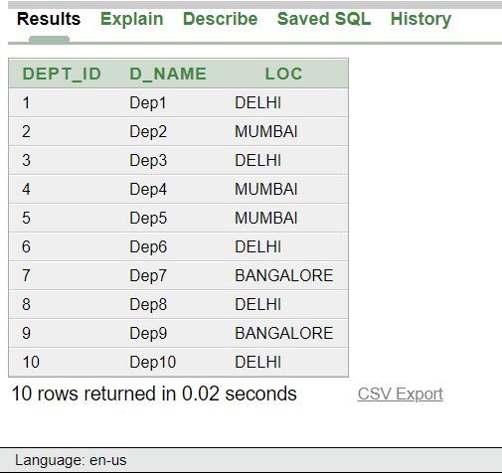

1. **Retrieve the data from EMP table.**

SELECT *from emp_table;

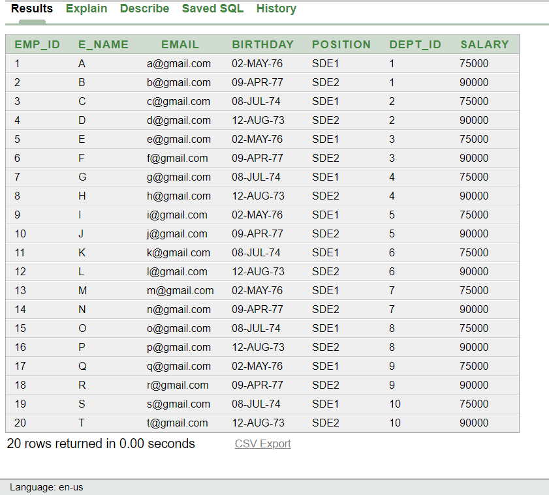

1. **Join both the tables EMP and DEPARTMENT.**

SELECT *FROM emp_table JOIN dept_table

ON emp_table.dept_id = dept_table.dept_id

ORDER BY emp_id;

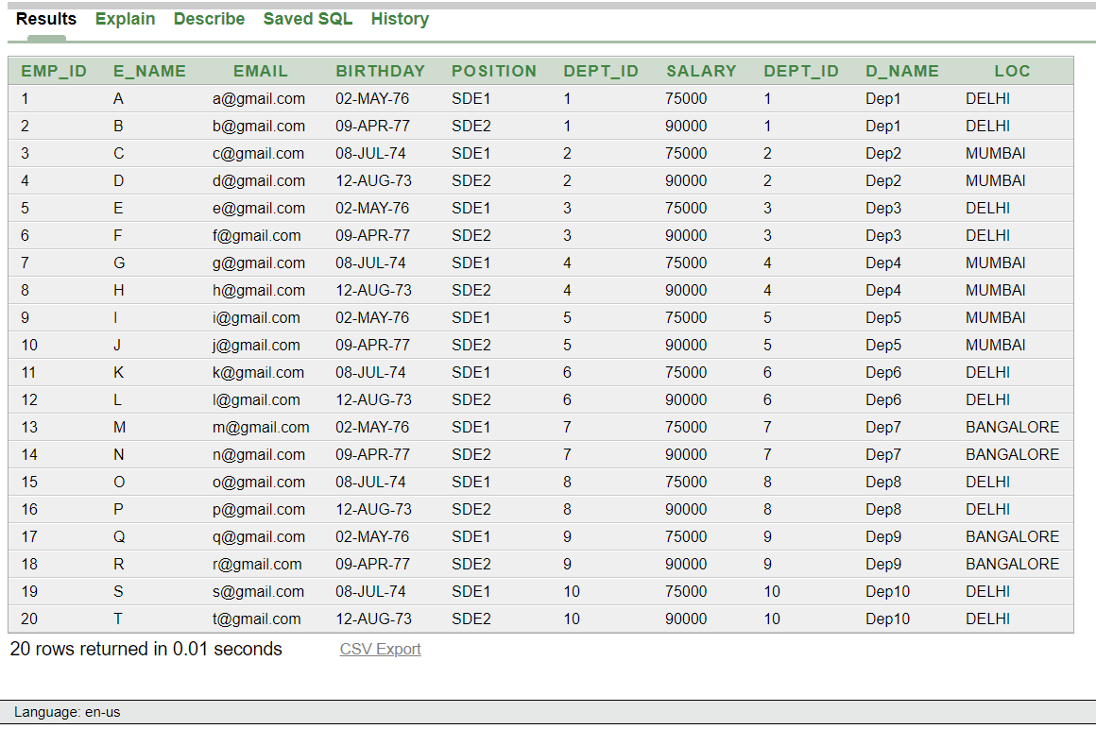

1. **Delete some data from Table.**

DELETE FROM emp_table where emp_id=16

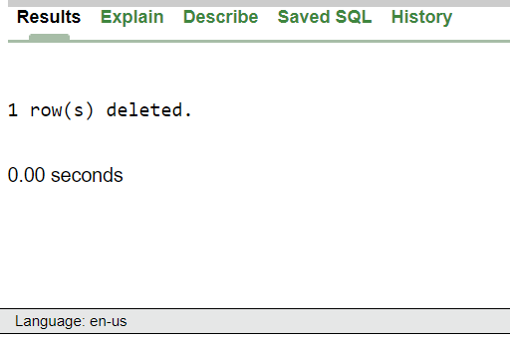

1. **Calculate data (For example: - student marks and percentage or employee salary and taxes)**

Add a column Hike in dept_table, which denotes multiplication factor to obtain ‘NET SALARY’ after Hike. Here we are assumning that hike of every department is different.

alter table "DEPT_TABLE" add

("HIKE" NUMBER NULL)

UPDATE dept_table

SET HIKE = 1.5

where dept_id > 5

UPDATE dept_table

SET HIKE = 1.2

where dept_id <= 5

Calculation Query

SELECT emp_table.emp_id,

emp_table.e_name,

emp_table.salary * dept_table.hike AS "NET SALARY"

FROM emp_table JOIN dept_table ON emp_table.dept_id = dept_table.dept_id

ORDER BY emp_id

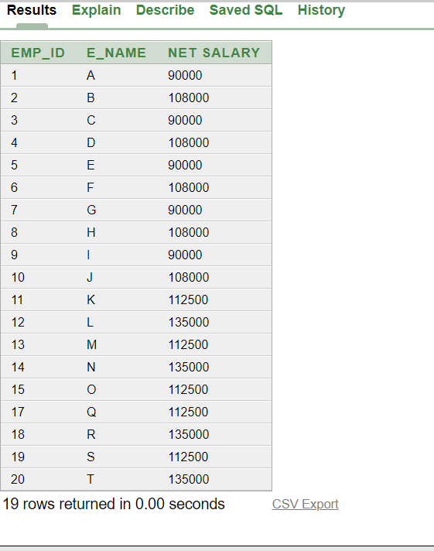

1. **Ordering of Data (ascending and descending order)**

SELECT *from dept_table

ORDER BY loc

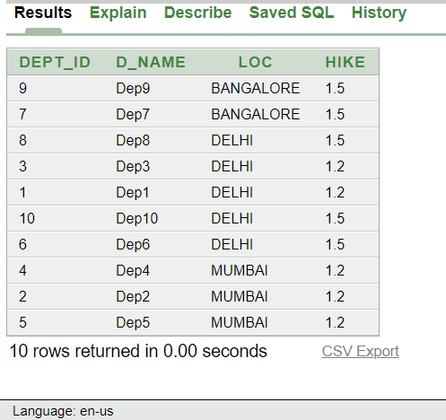

SELECT *from dept_table

ORDER BY loc DESC

